1. The key point is to make your dataset the same as the style shown in the following picture.



For ISIC data, we have 9 classes including AK, BCC, BKL, DF, MEL, NV, SCC, TT and VASC. And for each folder, it contains the images belong to the same class. For example, the fold AK contains all images belong to class AK.

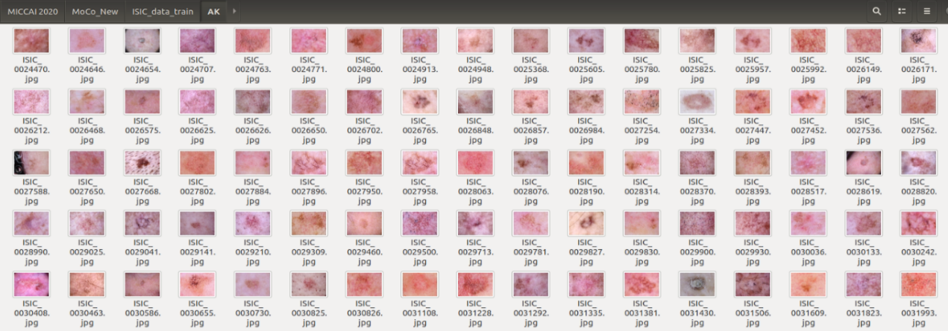

1. After you make the dataset the same as the picture above. You can use the defined dataset class **ImageFolderInstance** (datasets.ImageFolder) and Dataloader(torch.utils.data.DataLoader) class to load data directly.

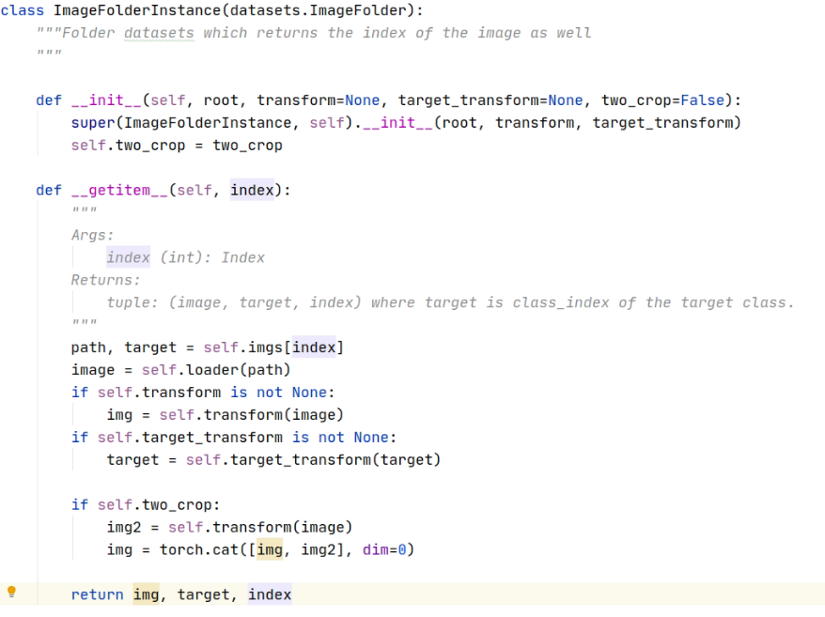

Because the class **ImageFolder** is designed to deal with this dataset style directly. Please refer to <https://pytorch.org/docs/stable/torchvision/datasets.html?highlight=imagefolder#torchvision.datasets.ImageFolder>

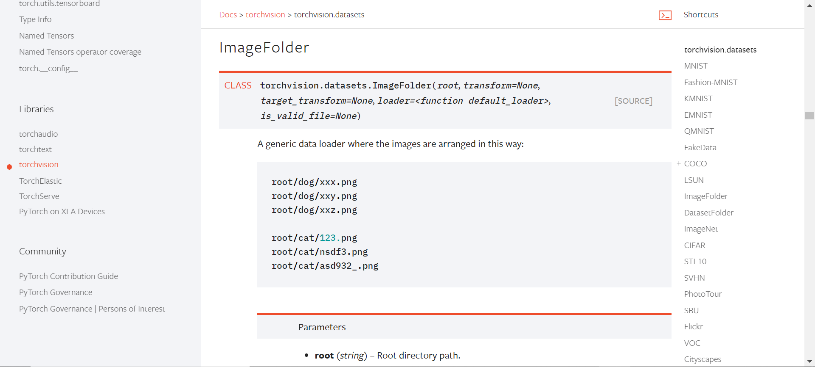

1. So, the most important is to make your dataset the same as the first step. You can write some codes to read the label (from csv file or others) of each image, and then move the image to the folder it belongs to.